CS 255 System Design Document Template

UML Diagrams

UML Use Case Diagram
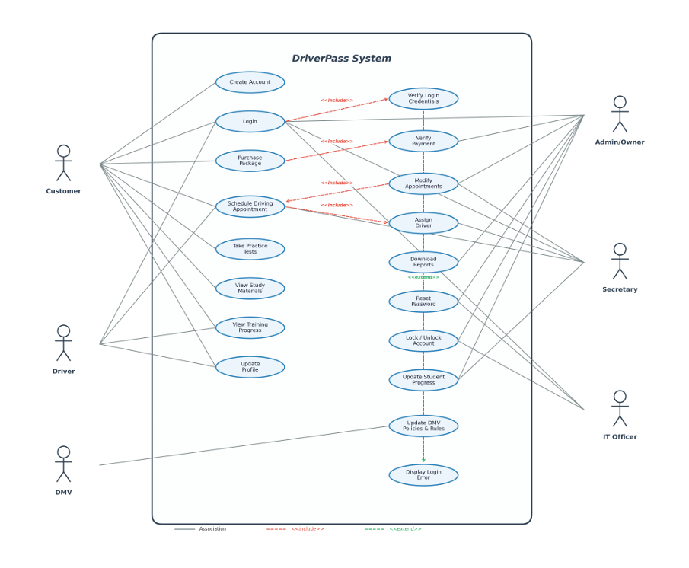

UML Activity Diagrams
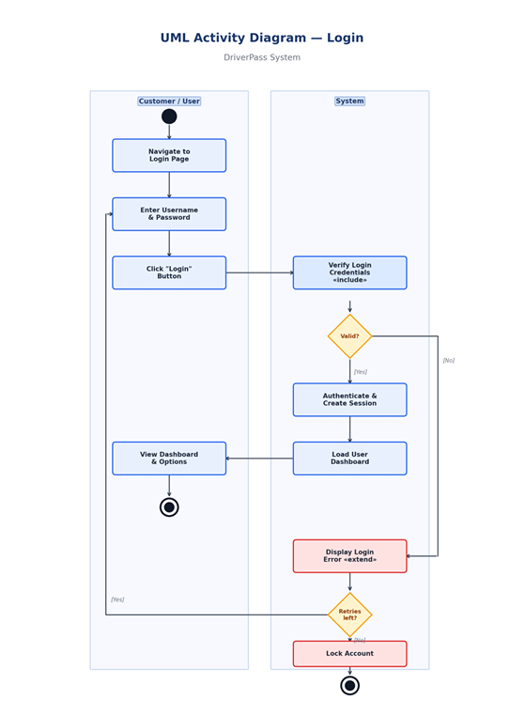
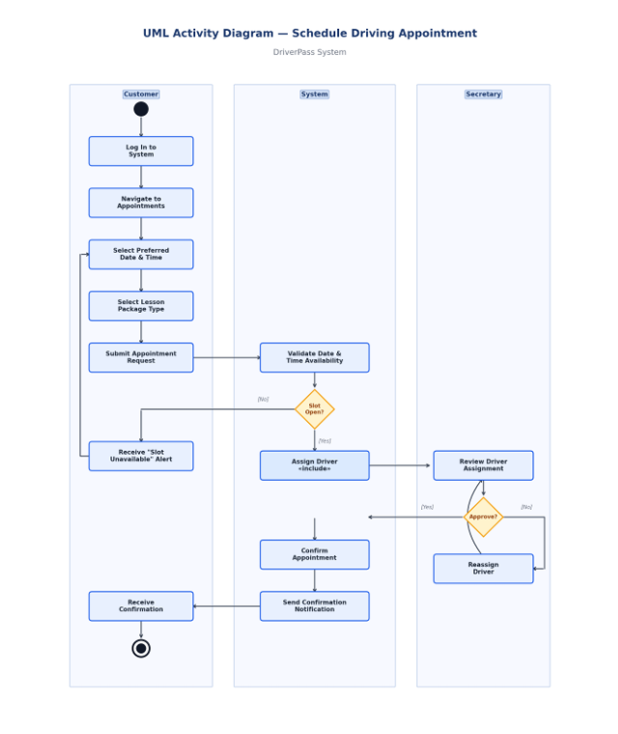

UML Sequence Diagram
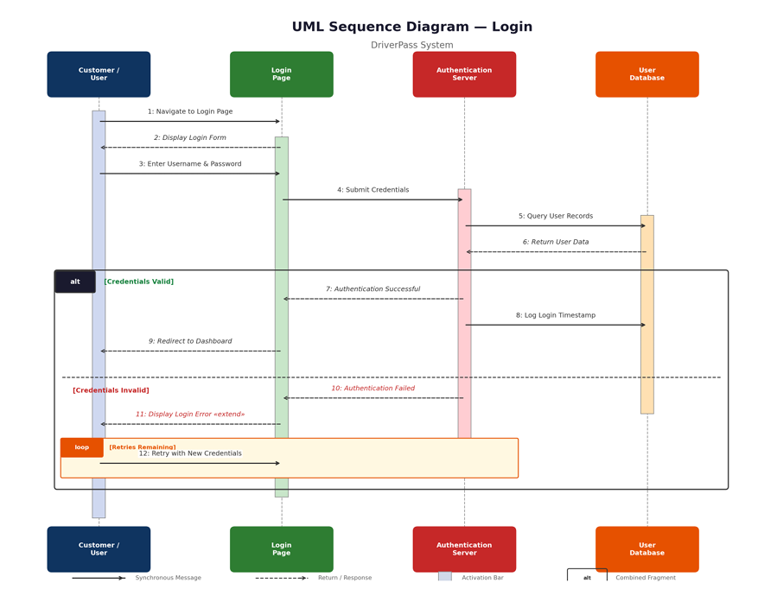

UML Class Diagram
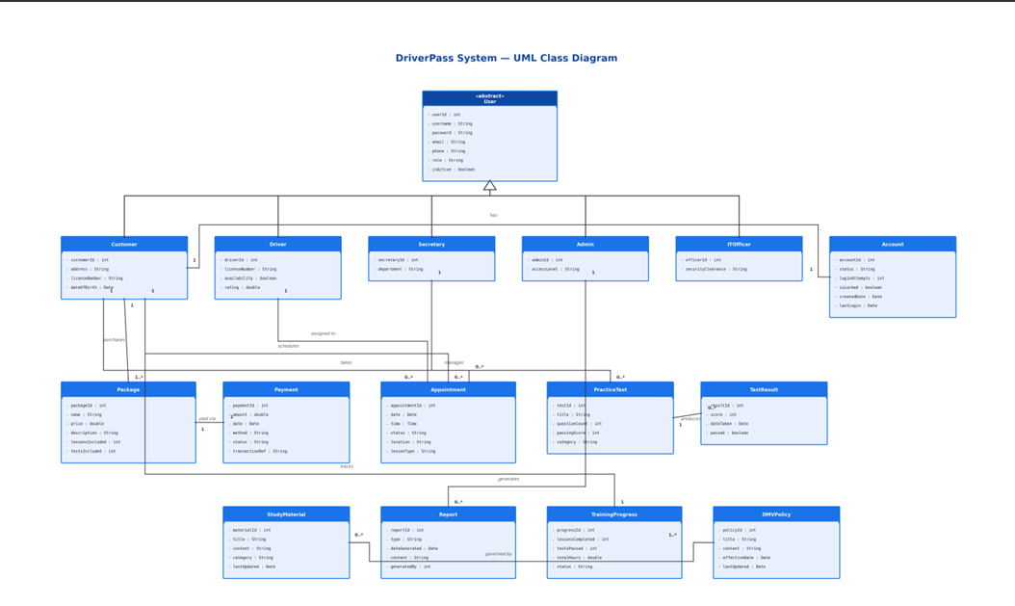

Technical Requirements
Hardware
The DriverPass system is web-based and does not require specialized hardware. Customers, drivers, and staff can access the platform using standard devices such as desktop computers, laptops, tablets, or smartphones with a modern web browser and internet connection. On the server side, DriverPass requires a dedicated or cloud-hosted web server with sufficient processing power and memory to support multiple users performing tasks such as logging in, scheduling appointments, purchasing packages, and taking practice tests simultaneously. A separate database server or instance is also needed to store user accounts, appointment records, payment transactions, test results, training progress, and DMV policy data, as shown in the class diagram.

Software
The sequence diagram illustrates that the system requires a front-end web application for user interfaces, a back-end application server for business logic, and a database management system for record storage and retrieval. The front end should use responsive web technologies to ensure compatibility across devices. The back end will manage core functions from the use case diagram, including account creation, credential verification, payment processing, appointment scheduling, driver assignment, and report generation. A relational database management system such as MySQL or PostgreSQL will support the structured data relationships in the class diagram, including the inheritance hierarchy from the abstract User class to Customer, Driver, Secretary, Admin, and IT Officer.

Tools
System development will require a version control tool such as Git for code management, a project management platform for task coordination, and an integrated development environment for coding and testing. Lucidchart was used to create UML diagrams outlining the system design. A payment gateway API, such as Stripe or PayPal, will be needed for payment verification, and an email or notification service will be required to send appointment confirmations to customers.
Infrastructure
Given Liam’s preference for a cloud-based system, DriverPass should be hosted on a cloud provider such as AWS, Microsoft Azure, or Google Cloud Platform. Cloud hosting offers key benefits for DriverPass, including automatic scaling, built-in redundancy to reduce downtime, and regular backups to protect critical data such as customer accounts, payment records, and training progress. The system must use HTTPS encryption for all user-server communications to safeguard sensitive information, including login credentials and payment details. This requirement is supported by the security measures outlined in the sequence and activity diagrams, such as login attempt limits and account locking. The infrastructure should also enable integration with DMV external systems to ensure policies and rules can be updated as needed, as indicated by the DMV actor in the use case diagram.

